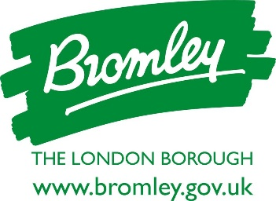

London Borough of Bromley News Release

18 September 2024

For immediate release

Welcome news securing the future of Churchill Theatre

The council is delighted to announce that an offer has been accepted, which can enable the future of Bromley town's much-loved theatre to be secured.

The news follows extensive discussions with the theatre’s current operators, Trafalgar Theatres (the theatre division of global live entertainment business, Trafalgar Entertainment), and an invitation earlier this year for expressions of interest that crucially would give long term security for the theatre. The Executive agreement is subject to the completion of a legal agreement, with the successful bidder being named at that point.

Councillor Yvonne Bear, Executive Councillor for Renewal, Recreation and Housing, said, “This is very welcome news, not just for the theatre and everyone who values it but also for Bromley town centre as a whole and for council taxpayers. This is a compelling and exciting opportunity to secure the future of the theatre for generations to come. We look forward to working with the theatre and the developer in the coming months and will share more news when we can.”

Councillor Colin Smith, Leader of Bromley Council said, “I am absolutely thrilled to be able to report this massive step forward to securing Churchill Theatre’s long-term future, following the last year of hard work, negotiations and planning behind the scenes.”

Councillor Smith continued, “We are now tantalisingly close to delivering on our promise to preserve and improve the theatre well into the 21st century, despite the scepticism and unpleasant scare mongering of some at the outset of this exercise, notwithstanding the incredible financial pressure engulfing public finances.”

Helen Enright, Chief Executive Officer of Trafalgar Theatres said, “We are excited about the future of the Churchill Theatre and will be pleased to work with the bidder to develop Bromley's theatre offering. In the meantime, I would encourage Churchill Theatre goers to keep supporting us by coming to see our fantastic shows, including the forthcoming Christmas pantomime.”

The decision to invite expressions of interest followed confirmation last year that the theatre, which was constructed in the 1970s, is now rapidly approaching the end of its design life. The relocation of Bromley’s Central Library to a more prominent location on the High Street, at the vacant Top Shop premises slightly nearer to Market Square, has also been agreed.

ENDS
For media enquiries, please contact Andrew Rogers, Head of Public Affairs, on 020 8461 7670 or email Andrew.Rogers@bromley.gov.uk.

