Annual Dinner

Beaverwood Place, The Beaverwood Club

Thursday 8th October, 2015

Speaker: Rt. Hon. Sajid Javid MP
Beaverwood Place is the beautiful new function venue, set within extensive private grounds in Chislehurst, Kent. You are invited to join us at this fantastic venue for an evening of good food and conversation where our Guest Speaker will be Sajid Javid, the Conservative Member of Parliament for Bromsgrove, Secretary of State for Business, Innovation & Skills and President of the Board of Trade.

Sajid was first elected Member of Parliament for Bromsgrove in May 2010, and was appointed a Privy Councillor by HM The Queen in 2014. Born in Rochdale, he attended state school before studying Economics and Politics at Exeter University. He joined the Conservative Party in 1988 and before public service he had a highly successful career in banking.

He has been engaged in community work his entire adult life, including leading a charity expedition to the summit of Mount Kilimanjaro for Help the Aged, and is Vice President of Bromsgrove Rugby Football Club.

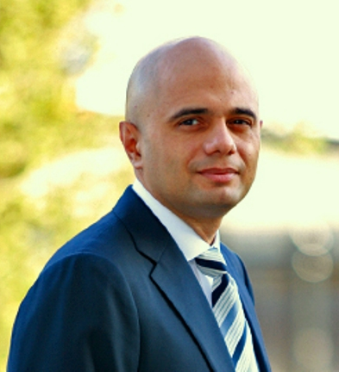
Sajid Javid, MP for
Bromsgrove

The Place: Beaverwood Place, The Beaverwood Club, Beaverwood Road, Chislehurst, BR7 6HF

The Time: Dinner to be served at 8pm, (refreshments available from 7pm).

The Price: £ 45.00 per person – (£ 405.00 for a table of 10 booked together)

Dress code: Black Tie or Dark Lounge Suit

For further details about the event, to pay by credit card, by PayPal or to discuss your requirements
please call the Association Office on 020 8295 2639.

--------------------------------------------------------------------------------------------------------------------------------------
Application Form

I would like to book………..places at £45.00 per person for the 2015 Annual Dinner at Beaverwood Place for 8th October 2015 and

enclose a cheque for £……………. Cheques payable to ‘Bromley & Chislehurst Conservative Association’

Name: __________________________________________ Names of guests: ____________________________________________

Address ____________________________________________________________________________________________________

Email: __________________________________________________Tel No:_______________________________________________

Please indicate any special dietary requirements:…………………………………………………………………...………………………………

Please return this slip and your cheque (if applicable) in the reply envelope enclosed.

Promoted & printed by Andrew Lee on behalf of Bromley & Chislehurst Conservatives, 5 White Horse Hill, Chislehurst, Kent BR7 6DG

